Goal: Make a portrait of your pet in the style of Andy Warhol. If you don’t have a pet, it could be a past pet, a friend or family member’s pet, or your favourite animal.
Andy Warhol POP ART Pet Portraits
Key Features:
- Bold & high contrast
- Bright complementary colours (opposites on the colour wheel)
- Repetition
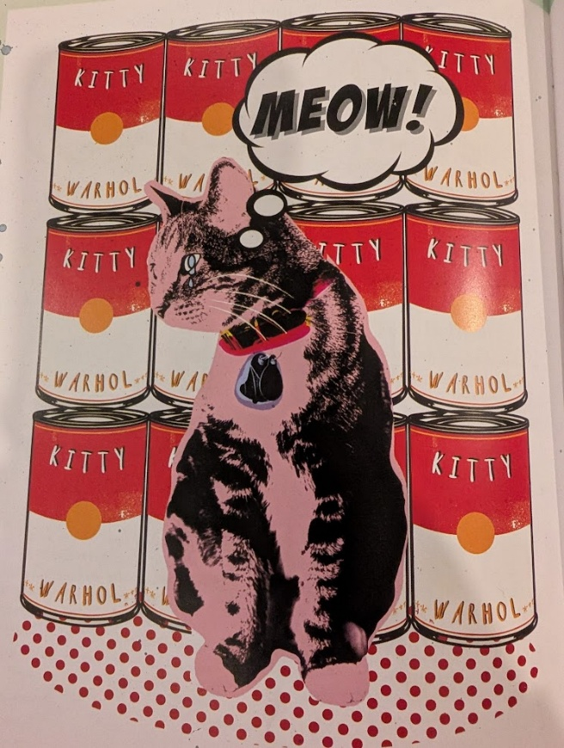
Step 1: Background
- Think of an everyday item your pet loves…
- Can of food, dog treat, yarn, ball, toy, carrot, car, etc.
- Trace this item to make a repeating background
Step 2: Pet Portrait
On a separate piece of paper, draw your pet/ animal of choice.
Make sure you…
- Give it lots of personality
- Use bold lines
- Plan where your colours will go
Step 3: Plan your colours
- Use bold, bright colours
- Choose complementary colours to really make your subject POP from the background.
(For example a cool background and warm colours on the subject).
Step 4: Colour, Cut & Paste
- Use paint, markers, or oil pastel to create solid, bold, colours
- Outline in sharpie/ black
- Cut out your pet/ animal
- Glue it on the background
VOILA! You’re done!

