Passion project!!

Goal: Develop critical thinking and build the skills to become a lifelong learner.
Curricular Objectives (Language Arts)*:
*Students will be primarily assessed in Language Arts, but since they can choose any question from a variety of topics, their project may be cross-curricular and connect to other subjects such as Science, Socials, Art, etc.
- Form and communicate their own ideas and viewpoints to extend critical thinking
- Access information and ideas for diverse purposes and from a variety of sources and evaluate their relevance, accuracy, and reliability

From now until June, you will have the opportunity to explore your passions. Your passion may be a topic you would not usually get to learn about in school (such as the universe, or the legend of bigfoot), or something you are curious about (like the internet). Your goal is to take something you are interested in and ask a deep, thoughtful question that is “non-googleable”. Questions like why are there so many different legends about bigfoot, yet they are all so similar? Or Has the internet impacted the world for better or for worse? These are thick questions.
You will be given 30-60minutes a week to work on this project. You must complete a MINIMUM of TWO passion projects. You could do a booklet, powerpoint, essay, prezi, podcast, web page, etc.… but you need to be able to hand it in online to Teams.
- Due March 16th, 2020. 2) Due June 11th, 2020
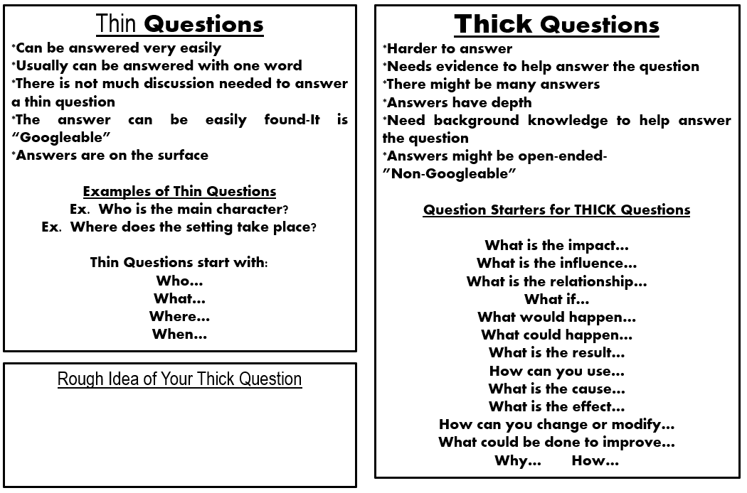
Passion Project Rubric
 | Beginning | Developing | Practicing | Extending
Inquiry/ Question | You can develop a research project on a topic. Is not an inquiry project. | You can develop a thin question independently.  Answer is google-able. | You can develop a thick question that provokes more investigation.  Answer is non-googleable. | You an develop a thick question that provokes complex investigation.
Research  Types of sources:  website, book, magazine, own research, newspaper, documentary, interview, etc.) | Used 1-2 sources.  (All same type of source).  Sources not cited. | Used 3 sources.  Your research summarizes other’s ideas.  (All same type of source).  All sources are cited. | Used 4 sources from reliable sources.  Your research supports your own ideas.  Includes two types of sources.  All sources cited, attempted MLA format. | Used 5+ sources  Cross-checked sources for accuracy.  You conducted your own research that extends your ideas.  Includes three types of sources.  All sources cited in MLA format
Written  *Must be entirely in your own words. Not copied. | Difficult to read. Ideas are incomplete.  Multiple errors.  Sentences copied from research. Messy writing. | Some awkward sentences. Written in full sentences.  A few minor errors.  Typed/ neatly written. | Easy to read, well-written in full paragraphs.  No errors.  Typed/ neatly written and fine lined. | Easy to read and written in full organized paragraphs (introduction, details, conclusion).  Writing is engaging.  Typed/ neatly written and fine lined.
Visual | Information is difficult to follow. No clear structure. | Information is mostly organized. Information is easy to follow, but some areas are awkward. | Information is organized. I can read and interpret your poster/powerpoint/ etc. | Information neatly organized and structured. It is easy to read and interpret.
Presentation  - 5 minutes  Body  Eye contact  Volume  Tone of Voice  WOW factor* | Shared some key facts. Addressed question.  Struggles with elements of public speaking. | Clearly addressed and answered their question.  Is developing some elements of public speaking. | Summarized question and answer in an organized manner.  Is competent in most elements of public speaking. | Summarized question and answer effectively and concisely.  Has mastered the 4 elements of public speaking.  Engaging or ‘WOW’ factor

*WOW factor- created something extra to engage the audience.

