Factors and Fractions (Equivalent & Simplest Form) Quiz

Name:

- Find the Greatest Common Factor for the following. (6 marks)
Ex. 40 and 12
12: 1, 2, 3, 4, 6, 12
GCF= 4
40: 1, 2, 4, 5, 8, 10, 20, 40

a. 8 and 14 b. 16 and 48

- Write two equivalent fractions for the shaded part of each picture.
(4 marks)

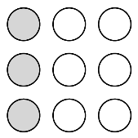
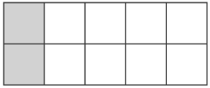
a) b)

- Write an equivalent fraction with a denominator of 30. (2 marks)

- $\frac{2}{3}$ = b) $\frac{8}{60}$ =

- Find the GCF and write in Simplest Form. (2 marks)

a)$\frac{8}{24}$ = b) $\frac{14}{63}$=

