A close up of a logo

Description generated with very high confidence

* TITLE…  
  Brain of (Animal) Compared to a Human

DESCRIPTION of your body system

4-8 sentences which include all of the following information:

* What is the brain’s role in the nervous system/ body? (What does it do, how does it help us survive…)
* How does it work with other body systems? (I.e. circulatory, respiratory, digestive, etc.)

FUN FACTS

* What do you find most interesting about your animal?
* A cool fact about your body system.
* DIAGRAM OF HUMAN BODY SYSTEM

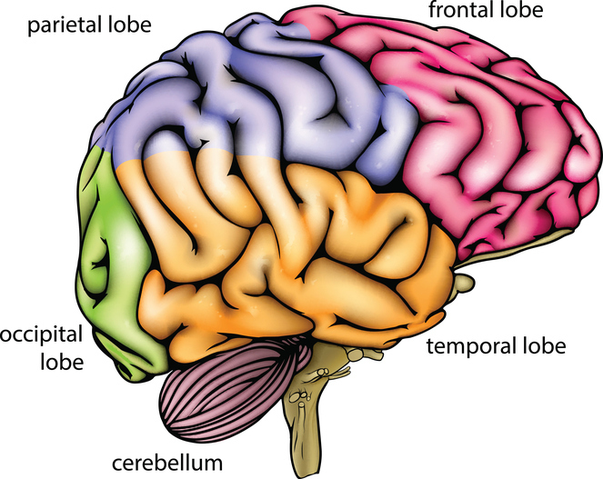

DIAGRAM OF ANIMAL & HUMAN BRAINS

* Parts of Brain labeled
* Animal: Description of what each part of the brain does
* Human: Description of what each part of the brain does
* DIAGRAM OF ANIMAL’S BODY SYSTEM

COMPARISON

* Draw a venn diagram of the similarities and differences of the brain of your animal and a human
* Think about size, lobes of the brain, senses, and complexity in your comparison

Human Bear

**Did you include….**