Brain:
Video- Human vs animal brains
https://www.youtube.com/watch?v=iCXSZQSWwdM&ab_channel=BusinessInsider

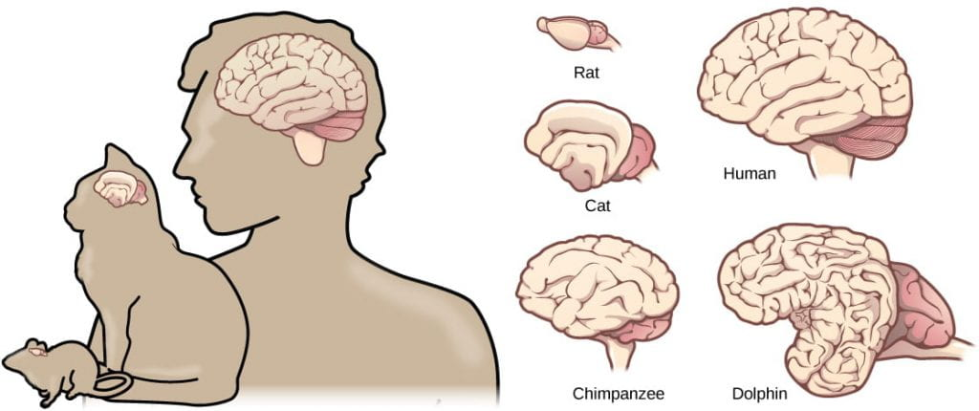
https://organismalbio.biosci.gatech.edu/chemical-and-electrical-signals/nervous-systems/
Reptile/ Crocodile/ Aligator: https://cdn.britannica.com/41/73341-050-FD402A57/brain-reptiles-olfactory-bulb-caiman-structure.jpg
Fish: https://cdn.britannica.com/39/73339-050-501A712B/cerebellum-importance-brain-fish-functions-balance-muscle.jpg
Bird/ goose: https://cdn.britannica.com/42/73342-050-82086FC0/lobe-brain-bird-fuctional-centre-lobes-cerebrum.jpg
Dolphins: https://www.seawatchfoundation.org.uk/latest-news-2/dolphin-brains/
https://us.whales.org/whales-dolphins/how-intelligent-are-whales-and-dolphins/
Dog: https://toegrips.com/wp-content/uploads/focal-brainmap-JGDP.jpg
https://www.dogster.com/lifestyle/dog-brain-vs-human-brain
https://www.dreamstime.com/anatomy-canine-brain-dog-veterinary-illustration-image241215625
Rabbit (a little tricker): https://www.yaclass.in/p/science-state-board/class-10/structural-organisation-of-animals-11626/oryctolagus-cuniculus-rabbit-11684/re-47fbfb53-d047-4db3-b51b-780ad8e367de

